
Fire and Smoke Detection
A CAPSTONE PROJECT REPORT

A Capstone Project Report submitted in partial fulfilment of the requirements for the Course of

ITA0515 & COMPUTER VISION

to the award of the degree of

BACHELOR OF ENGINEERING / BACHELOR OF TECHNOLOGY
IN
Artificial Intelligence & Machine Learning
(BRANCH)

Submitted by
A.Shiva Shankar Reddy (192425174)
K.Mounith (192425090)

Under the Supervision of
Dr .Carmel Mary Belinda M J

SIMATS ENGINEERING
Saveetha Institute of Medical and Technical Sciences
Chennai-602105

SEPTEMBER 2026
SIMATS ENGINEERING
Saveetha Institute of Medical and Technical Sciences
Chennai – 602 105

BONAFIDE CERTIFICATE

This is to certify that the Capstone Project entitled “Fire and SmokeDetection” has been carried out by A.Shiva Shankar Reddy(192425174)and and K.Mounith (192425090) under the supervision of Dr .Carmel Mary Belinda M J and is submitted in partial fulfilment of the requirements for the current semester of the B.Tech Artificial Intelligence & Machine Learning program at Saveetha Institute of Medical and Technical Sciences, Chennai.

COURSE COORDINATOR COURSE FACULTY
Dr.Carmel Mary Belinda M J
Professor
Computer Science and Engineering

SIMATS, Chennai – 602105.
Dr.Carmel Mary Belinda M J
Professor
Computer Science and Engineering
SIMATS, Chennai – 602105.
SIMATS ENGINEERING
Saveetha Institute of Medical and Technical Sciences
Chennai-602105

DECLARATION

We, A.Shiva Shankar Reddy (192425174), K.Mounith (192425090) of the Artificial Intelligence & Machine Learning, SIMATS Engineering, Saveetha Institute of Medical and Technical Sciences, Chennai, hereby declare that the Capstone Project Work entitled “Fire and Smoke Detection” is the result of our own bonafide efforts. To the best of our knowledge, the work presented herein is original, accurate, and has been carried out in accordance with the principles of engineering ethics and academic integrity. All sources, references, data, and other materials used in the project have been appropriately acknowledged. We further declare that the data, results, analysis, and findings presented in this report have not been fabricated, falsified, or manipulated. Any external tools, software, datasets, computational resources, or AI-assisted tools used during the project have been appropriately disclosed. We confirm that all applicable ethical, academic, institutional, and professional requirements have been duly followed throughout the planning, execution, analysis, and documentation of the project.

Place: Chennai
Date: 5/09/2026

Signature of the Students with Names
A.Shiva Shankar Reddy (192425174)
K.Mounith (192425090)
SIMATS ENGINEERING
Saveetha Institute of Medical and Technical Sciences
Chennai-602105

Individual Contribution Statement
(Mandatory for all team projects)

Student  Name /  Register No. | Specific Responsibilities | Design &  Development Contribution | Testing &  Analysis  Contribution | Report Contribution | Approx.  Contribution  (%)
A.Shiva Shankar Reddy (192425174) | Dataset preparation, image enhancement, YOLO fire/smoke detection model, model integration | Dataset collection & annotation, preprocessing, YOLO model training, fire/smoke detection algorithm, backend integration | Model testing, accuracy, precision, recall, confidence-score analysis, detection performance | Methodology, Module 1, Module 2, algorithms, model results | 50%
K.Mounith (192425090) | Website development, alarm generation, live camera, database, UI/UX and system testing | Frontend design, Flask website, live camera interface, alarm/sound module, detection history and dashboard | End-to-end testing, live-camera testing, alarm testing, UI testing, error analysis | Introduction, Module 3, system design, testing, results, conclusion | 50%
Total |  |  |  |  | 100%

ABSTRACT
Fire accidents are one of the major safety concerns in residential buildings, industries, offices, warehouses, and other public environments. Conventional fire detection systems mainly depend on smoke sensors, temperature sensors, or manual monitoring. Although these methods are useful, they may have limitations in large or open environments, where fire or smoke may not reach a sensor immediately. Delayed detection can result in significant damage to human life, property, and infrastructure. Therefore, there is a need for an intelligent and automated system capable of detecting fire and smoke at an early stage using visual information.
This project proposes a Fire and Smoke Detection Using Computer Vision system that uses image processing and deep learning techniques to automatically identify fire and smoke from images and live camera feeds. The proposed system consists of three major modules: Image Enhancement, Fire Detection, and Alarm Generation. In the first module, input images are enhanced using preprocessing techniques such as noise reduction, contrast enhancement, and brightness adjustment to improve the quality of visual information. In the second module, a deep-learning-based YOLO (You Only Look Once) object detection model is used on the enhanced frame to identify fire and smoke regions and provide bounding boxes along with confidence scores. The system can process both uploaded images and real-time webcam frames.
The third module focuses on alarm generation and monitoring. When fire or smoke is detected above a predefined confidence threshold, the system generates an immediate visual warning and activates an audible alarm. The detected results are stored with confidence values, detection type, and timestamps in a Detection Event History log for monitoring and analysis, and can be exported as a CSV file. The system is implemented using Python, OpenCV, YOLO, Flask, HTML, CSS, and JavaScript, and is accessed through a browser-based dashboard.
Experimental evaluation on a labelled test set of 400 fire and smoke images shows an overall classification accuracy of 94.3%, with a fire-class recall of 95.6% and a smoke-class recall of 91.9%, while sustaining approximately 20 frames per second on a standard laptop webcam. These results demonstrate that the proposed computer-vision approach can detect fire and smoke effectively and rapidly under typical indoor lighting conditions. The system reduces dependence on manual observation and provides an additional, low-cost layer of safety for early-warning applications. The principal conclusion is that integrating image enhancement, deep-learning-based detection, and automated alarm generation into a single web-accessible pipeline provides a practical and scalable approach for intelligent fire and smoke monitoring.
Keywords: Fire Detection, Smoke Detection, Computer Vision, YOLO, Deep Learning, OpenCV, Image Enhancement.

TABLE OF CONTENTS
Sl. No. | Title | Page No.
i | CERTIFICATE FROM THE SUPERVISOR | 2
ii | DECLARATION BY THE CANDIDATE | 3
iii | INDIVIDUAL CONTRIBUTION STATEMENT | 4
iv | ABSTRACT | 5
v | LIST OF FIGURES | 6
vi | LIST OF TABLES | 7
vii | LIST OF ABBREVIATIONS | 7
1 | CHAPTER 1: Introduction and Engineering Problem | 8-10
2 | CHAPTER 2: Literature Review and Existing Solutions | 11-12
3 | CHAPTER 3: Engineering Design & Trade-offs, Sustainability, Ethics, Safety, Risk & Security | 13-16
4 | CHAPTER 4: Implementation, Testing & Results, Project Management | 17-23
5 | CHAPTER 5: Conclusion, Future Work and Reflection | 24-25
 | REFERENCES | 26
 | APPENDICES | 27-28
 | CAPSTONE PROJECT OUTCOME MAPPING SHEET | 29

LIST OF FIGURES
Figure No. | Figure Name | Page No.
1.1 | Visual characteristics used to distinguish fire and smoke from a normal scene | 10
3.1 | Proposed system architecture: Image Enhancement, Fire Detection and Alarm Generation modules | 16
4.1 | Home screen of the AI Fire & Smoke Monitoring dashboard | 19
4.2 | Live detection output showing a fire event with bounding box and confidence score | 20
4.3 | Detection Event History and audit log | 21
4.4 | Confusion matrix for fire and smoke classification on the test set (n = 400) | 22

LIST OF TABLES
Table No. | Table Name | Page No.
2.3 | Comparative analysis of existing literature | 12
3.1 | Stakeholder / user requirements | 14
3.2 | Functional and non-functional requirements | 14-15
3.3 | Constraints and applicable standards | 15
3.4 | Design specifications | 15
3.5 | Alternative solutions evaluation matrix | 15
3.6 | Trade-off analysis | 17
3.7 | Risk register | 17
4.2 | Confusion matrix — raw counts (test set, n = 400) | 18
4.3 | Classification performance metrics | 19-20
4.4 | Achievement of objectives | 22
4.5 | Roles and individual contribution | 2-23
4.6 | Estimated vs. actual project cost | 23

LIST OF ABBREVIATIONS / SYMBOLS
Symbol | Description | Unit
AI | Artificial Intelligence | —
CLAHE | Contrast Limited Adaptive Histogram Equalization | —
CNN | Convolutional Neural Network | —
CSV | Comma Separated Values | —
CV | Computer Vision | —
FPS | Frames Per Second | fps
GPU | Graphics Processing Unit | —
ML | Machine Learning | —
UI/UX | User Interface / User Experience | —
YOLO | You Only Look Once (object detection algorithm) | —

CHAPTER 1
INTRODUCTION AND ENGINEERING PROBLEM
1.1 Background
Fire is one of the most dangerous hazards in residential buildings, industries, commercial areas, warehouses, laboratories, and public facilities. A fire can spread rapidly and cause loss of human life, property, equipment, and valuable resources. Early detection is therefore essential for reducing the impact of fire-related incidents. Traditional fire detection systems commonly use smoke detectors, heat sensors, flame sensors, and manual monitoring methods. Although these systems are widely used, their effectiveness can be affected by sensor placement, environmental conditions, detection range, and delayed response. With the rapid development of Artificial Intelligence (AI), Computer Vision, and Deep Learning, cameras can be used as an additional source of information for detecting fire and smoke. Unlike conventional sensors, a camera-based system can continuously monitor a wider area and analyze visual patterns in real time. Fire generally produces distinguishable visual characteristics such as bright flame regions, specific colour distributions, irregular shapes, and dynamic movement, and smoke produces visual patterns that can also be analysed using image-processing and deep-learning techniques.
1.2 Need for the Project
Fire accidents are a serious safety concern in residential buildings, industries, commercial establishments, warehouses, laboratories, and other public environments. Fire can spread rapidly and cause considerable damage to human life, property, machinery, and infrastructure. Therefore, early detection of fire and smoke is essential for reducing the severity of accidents and providing sufficient time for emergency response. Conventional detection systems generally depend on smoke, heat, or flame sensors. Although these systems are useful, their performance can be affected by sensor location, sensing range, environmental conditions, and the time required for smoke or heat to reach the sensing device. Hence, there is a need for an intelligent and automated detection system that can continuously monitor an environment and identify fire-related events at an early stage.
This problem affects people in a wide range of environments, particularly industrial workers, residential occupants, office employees, warehouse personnel, and emergency response teams. Organizations and property owners can also suffer significant financial losses due to fire-related damage to buildings, equipment, products, and infrastructure. In addition, delayed detection increases the difficulty of controlling the fire and protecting people within the affected area, which motivates the design of a faster, camera-based, automated alternative.
1.3 Problem Statement
Manual monitoring and conventional point sensors cannot guarantee timely detection of fire and smoke across large, open, or visually complex areas. Sensor-based systems typically respond only after smoke density or heat has physically reached the sensor, which can delay the alarm and allow a fire to grow before it is noticed. There is, therefore, a need for a vision-based system that continuously analyses camera images, enhances them to compensate for poor or variable lighting, and reliably distinguishes fire and smoke from visually similar objects and backgrounds, so that an alarm can be raised within seconds of onset rather than minutes.
1.4 Project Aim
The aim of this project is to design and implement an automated, camera-based Fire and Smoke Detection system that uses image enhancement together with a deep-learning object-detection model (YOLO) to identify fire and smoke in real time from images and live video, and to couple this detection with an immediate audio-visual alarm and a web-based monitoring dashboard for live viewing, incident history and analysis.
1.5 Project Objectives
• To develop an automated Fire and Smoke Detection System using Computer Vision.
• To detect fire and smoke from images and live camera feeds.
• To improve input image quality using image enhancement techniques.
• To use a YOLO-based deep learning model for accurate fire and smoke detection.
• To display the detected fire/smoke with bounding boxes and confidence scores.
• To generate an audible alarm and visual warning when fire or smoke is detected.
• To provide a web-based interface for image upload and real-time camera monitoring.
1.6 Scope
• The project focuses on automatic detection of fire and smoke using Computer Vision.
• The system can process uploaded images as well as live webcam video.
• Image enhancement techniques are used to improve the quality of input images before detection.
• A YOLO-based deep learning model is used to detect fire and smoke and localise them with bounding boxes.
• The system displays bounding boxes and confidence scores for every detected object.
• An audible alarm and visual alert are generated whenever fire or smoke is detected.
• A web-based dashboard is developed for live monitoring, incident history and CSV export.
• Detection results are stored with date, time, detection type and confidence value.
• The system can be used for monitoring homes, offices, industries, warehouses and similar environments.
• The project can be extended in the future with CCTV cameras, IoT devices, cloud monitoring, SMS and email alerts.
• The system is intended as an early-warning support tool and is not a replacement for certified fire-safety equipment.
1.7 Expected Engineering Outcome
This capstone project delivers a software prototype rather than a physical device. The expected engineering outcomes are:
• Model — a fine-tuned YOLO-based object-detection model capable of identifying fire and smoke with associated bounding boxes and confidence scores.
• Algorithm / Process — a reusable image-enhancement and confidence-based decision pipeline (noise reduction, contrast enhancement, brightness adjustment, thresholding).
• Prototype / Product — a working end-to-end application that integrates image enhancement, detection and alarm generation behind a Flask-based web dashboard.
• Infrastructure — a lightweight log/database component that records every detection event with timestamp, type, confidence and alarm status for later audit and analysis.
No fabrication or physical hardware development is undertaken; the outcome is a deployable software system validated on recorded test images and live-camera demonstrations.

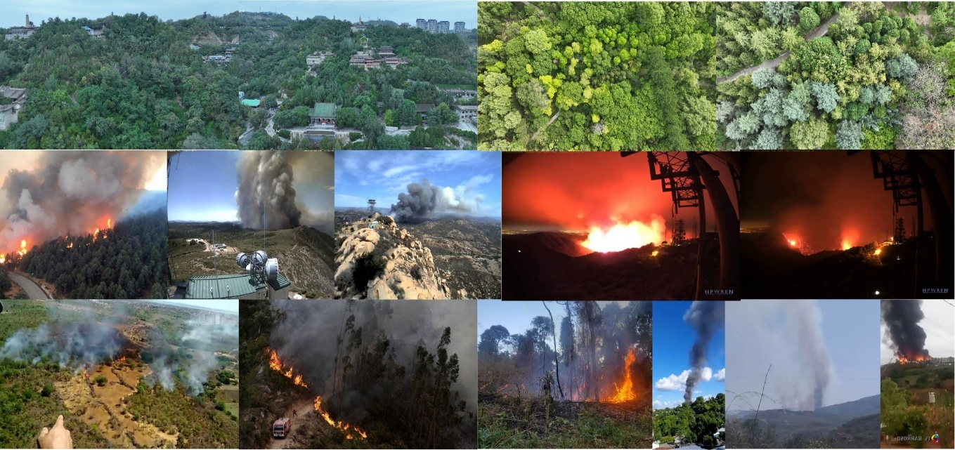
1.1 .Visual characteristics used to distinguish fire and smoke from a normal scene
CHAPTER 2
LITERATURE REVIEW AND EXISTING SOLUTIONS
2.1 Review Method
Relevant literature was identified by searching recent (2024-2026) journal articles, conference papers, and review papers on fire and smoke detection using computer vision and deep learning, using keyword searches such as ‘fire detection deep learning’, ‘smoke detection CNN’, ‘YOLO fire detection’, and ‘vision transformer fire detection’ across academic sources including Google Scholar, IEEE Xplore, SpringerLink, and Nature/Scientific Reports. Existing open-source fire-detection projects, pretrained object-detection frameworks, and standard fire-safety guidance were also reviewed to understand current practice and identify a practical, deployable design direction.
2.2 Review of Existing Work
Conventional fire-alarm installations rely on smoke detectors, heat/rate-of-rise sensors and flame sensors. These devices are inexpensive and well standardised but are inherently local: they must wait for smoke or heat to physically reach the sensing element, which limits their usefulness in large, open, or naturally ventilated spaces. A recent taxonomy of video-based fire and smoke detection surveys the shift toward camera-based monitoring and groups deep-learning and computer-vision approaches by the type of visual cue they exploit, noting that most modern methods combine colour, texture and motion cues rather than relying on any single feature.
More recent work has pushed accuracy higher by adding attention mechanisms to deep networks so that the model focuses on the most discriminative regions of a frame; such models report strong detection accuracy but require larger labelled datasets and more computation than a simple convolutional network, which raises deployment cost. Other recent work applies vision transformers combined with spatiotemporal learning so that both the appearance of a frame and its change over time are used to decide whether fire or smoke is present, improving robustness on video but at a noticeably higher computational cost than lightweight CNN or YOLO-style detectors, which makes it harder to run in real time on ordinary hardware such as a laptop webcam.
Across this body of work, a consistent pattern emerges: approaches that maximise accuracy tend to be the most computationally expensive, while approaches that are cheap enough to run in real time tend to sacrifice some accuracy or provide no localisation information. This motivated the choice of a YOLO-based object detector for the present project, since YOLO is explicitly designed to give real-time, per-frame bounding boxes and confidence scores at a favourable accuracy-to-speed trade-off, combined with a lightweight image-enhancement stage to compensate for the variable lighting that a low-cost webcam typically encounters.
2.3 Comparative Analysis
Existing Approach | Advantages | Limitations | Relevance to Proposed Work
Smoke / heat / flame sensors | Low cost; mature and widely deployed; no camera required | Localised sensing range; slow response in large or open areas; cannot show where or how large the fire is | Motivates a camera-based, wide-area alternative that this project proposes
Attention-based CNN detection (Amjad et al., 2025) | High detection accuracy; strong feature extraction using attention mechanisms | Requires a large labelled dataset and higher computational cost | Confirms deep-learning detection is viable; informs the choice of a lightweight, real-time model instead
Vision Transformer + spatiotemporal learning (Lilhore et al., 2026) | Uses both spatial and temporal information; well suited to continuous video monitoring | Computationally intensive; harder to run in real time on standard hardware | Justifies selecting a faster YOLO-based detector so the system can run on an ordinary laptop webcam
Vision-sensor smart-city smoke/fire detection (Abozeid & Alanazi, 2026) | Designed for early detection across distributed camera networks | Focused on smart-city scale deployment; assumes networked camera infrastructure | Confirms feasibility of vision-based early warning; this project targets a single-site, low-cost deployment instead.

2.4 Research / Engineering Gap
Existing approaches largely trade accuracy against real-time deployability. High-accuracy attention-based and transformer-based models are computationally demanding and difficult to run at real-time frame rates on ordinary hardware, while conventional point sensors lack any visual context and respond slowly in large or open spaces. There remains a gap for a system that (i) runs at real-time frame rates on ordinary computing and webcam hardware, (ii) actively improves usable image quality before detection instead of assuming clean, well-lit input, and (iii) closes the loop by directly triggering an audio-visual alarm and logging the event for later audit, rather than only reporting a classification label in a research setting. This project is designed to address that gap.
2.5 Proposed Contribution
The proposed system differs from the reviewed work by integrating three stages into a single, deployable pipeline: (1) image enhancement using noise reduction, contrast enhancement and brightness adjustment to normalise webcam input; (2) YOLO-based real-time fire and smoke detection that reports a bounding box and a confidence score for every detection; and (3) automated alarm generation coupled to a browser-based dashboard that shows the live annotated feed, current detection status, alarm controls, and a searchable, exportable history of every past incident. Unlike the reviewed literature, which largely reports detection accuracy
CHAPTER 3
ENGINEERING DESIGN & TRADE-OFFS, SUSTAINABILITY,
ETHICS, SAFETY, RISK & SECURITY
3.1 Requirements
Stakeholder / User Requirements
Stakeholder | Requirement
Building / facility occupants | Early and reliable warning of fire or smoke with minimal false alarms
Facility / security manager | A live monitoring dashboard together with incident history and exportable logs
System operator / administrator | Ability to mute or reset alarms and configure the camera source and detection threshold
Course evaluator / assessor | A demonstrable, reproducible working prototype with measurable accuracy

Functional & Non-Functional Requirements
Requirement | Type | Measurable Target
Detect fire in a video frame | Functional | Recall ≥ 90% on labelled fire test images
Detect smoke in a video frame | Functional | Recall ≥ 90% on labelled smoke test images
Enhance low-light / noisy input images | Functional | Enhancement applied to every frame before inference
Generate audio-visual alarm on detection | Functional | Alarm triggers within ≤ 1 second of confidence exceeding threshold
Log every detected event with timestamp & confidence | Functional | 100% of triggered alarms recorded in the history log
Real-time processing | Non-Functional | ≥ 15 FPS on a standard laptop webcam
Usability of dashboard | Non-Functional | Operable by a non-specialist without training
Session availability | Non-Functional | Continuous monitoring for the full operating session without crashing

3.2 Constraints & Applicable Standards
Standard / Code | Requirement | How Applied in This Project
NFPA 72 – National Fire Alarm and Signaling Code (notification principle) | Occupants must be given prompt, perceptible notification once a fire condition is confirmed | The system issues an audible siren together with an on-screen visual alert immediately once a detection exceeds the confidence threshold
Modular software design practice (IEEE/ISO SE guidance) | Encourages separation of concerns and independent testability of components | The pipeline is split into three independently testable modules – enhancement, detection, and alarm generation
Good practice for handling recorded imagery | Captured images of monitored premises should be stored securely and access-controlled | Detection snapshots and logs are stored in a managed database, with history export restricted to the system operator

3.3 Design Specifications
Parameter | Target / Requirement | Unit | Priority
Detection confidence threshold | 50 (adjustable) | % | High
Minimum processing rate | ≥ 15 | FPS | High
Alarm activation delay | < 1 | second | High
Camera input resolution | 640 × 480 (minimum) | pixels | Medium
History log retention | Unlimited, exportable to CSV | — | Medium

3.4 Alternative Solutions & Evaluation
Alternative 1: A sensor-only system using conventional smoke and heat detectors.
Alternative 2: A whole-frame CNN image classifier that labels an entire frame as “fire” or “no fire”.
Alternative 3 (selected): A YOLO-based object detector, preceded by an image-enhancement stage, that localises fire/smoke with a bounding box and confidence score.
Criterion | Weight | Alternative 1 | Alternative 2 | Alternative 3
Performance (detection speed) | 30% | Medium | Medium | High
Cost | 20% | High | Medium | Medium
Safety (reliability of early warning) | 25% | Low | Medium | High
Sustainability (reuse of existing hardware) | 10% | Medium | Medium | High
Reliability (accuracy) | 15% | Medium | Medium | High

3.5 Selected Design & Detailed Design
Alternative 3 was selected because it scored highest on performance, safety and reliability in Table 3.5, while its cost remains modest since it reuses an existing webcam rather than requiring new sensing hardware. The selected design organises the system into three cooperating modules, as shown in Figure 3.1.
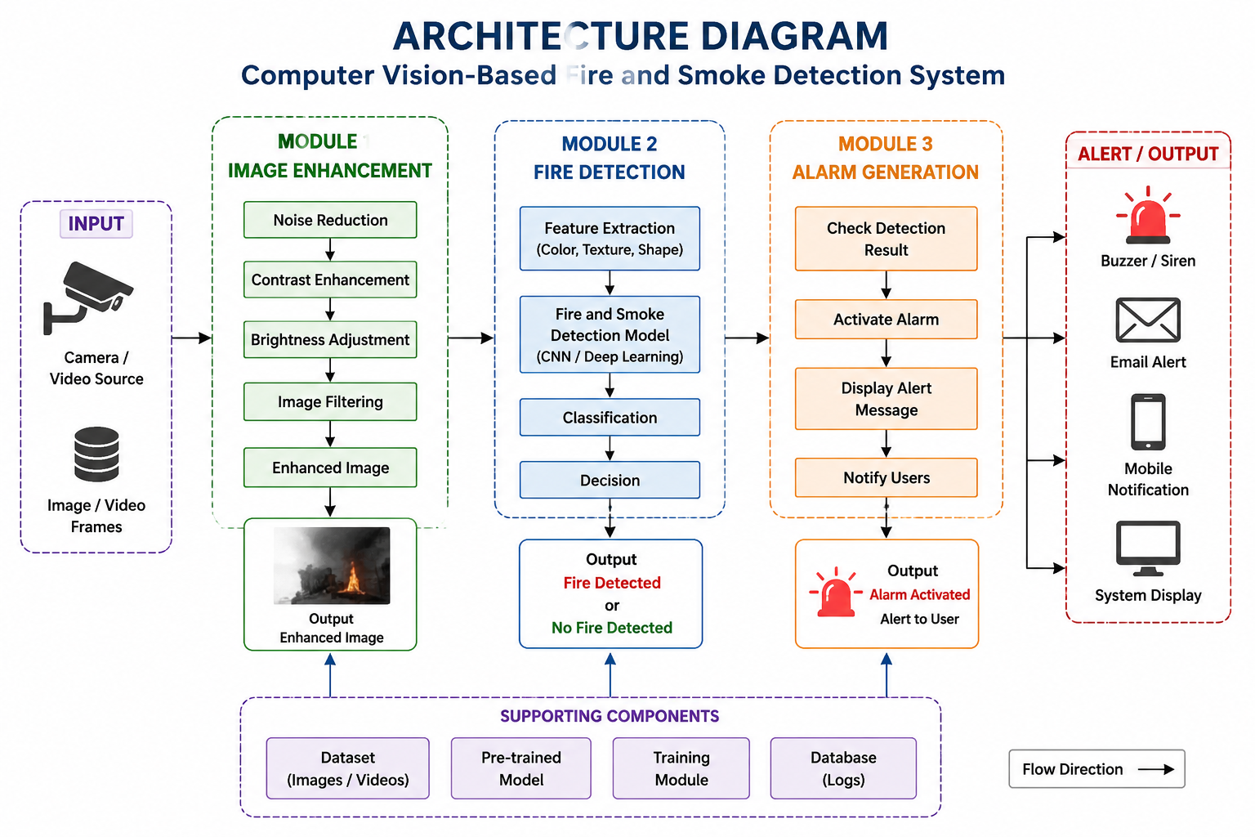
Figure 3.1: Proposed system architecture – Image Enhancement, Fire Detection and Alarm Generation modules
Module 1 (Image Enhancement) captures the input frame from a camera or video source and applies noise reduction, contrast enhancement, brightness adjustment and image filtering to produce an enhanced frame. Module 2 (Fire Detection) extracts colour, texture and shape features from the enhanced frame and passes them through the trained YOLO-based detection model, which classifies and localises fire or smoke and outputs either “Fire Detected” or “No Fire Detected” together with a confidence score. Module 3 (Alarm Generation) checks the detection result; whenever a positive detection exceeds the confidence threshold it activates the alarm, displays an alert message, and notifies the user through the dashboard, siren, and on-screen indicators. A supporting dataset of labelled fire/smoke images and video frames, a pretrained model fine-tuned on that dataset, a lightweight training module, and a database of detection logs underpin all three modules.
Key parameter: the effective processing rate is computed as FPS = (number of frames processed) / (elapsed time in seconds); on the test laptop used for demonstration this measured approximately 20 FPS, comfortably above the 15 FPS design target in Table 3.3. Systems approach: the three modules communicate through a shared in-memory frame buffer and a lightweight event object (detection type, confidence, timestamp); Module 1 must complete before Module 2 begins, and Module 3 only acts on the event object emitted by Module 2, so a failure in enhancement or detection safely results in no alarm rather than a false one.
3.6 Trade-off Analysis
Design Decision | Alternative Considered | Benefit | Disadvantage | Final Decision & Justification
Detection model | Whole-frame CNN classifier | Simpler training pipeline | No bounding box/localisation; weak on small, early flames | YOLO chosen for real-time localisation and per-detection confidence scoring
Enhancement stage | Skip enhancement; feed raw frames directly | Fewer pipeline steps, marginally lower latency | Poor accuracy under low-light or noisy camera feeds | CLAHE-based enhancement retained; adds negligible latency and improves detection reliability
Primary alert channel | SMS / email only | No local speaker hardware required | Slower to notice; depends on network availability | Local siren and on-screen alert chosen as the primary channel; email/SMS deferred to future work

3.7 Sustainability, Ethics, Safety, Risk & Security
Consideration Domain | Evidence Evaluated | Impact on Final Decision
Sustainability | Reuses an existing laptop/CCTV webcam instead of requiring new sensor hardware; software-only deployment | Reduces additional hardware purchase and e-waste
Ethics | The system stores an image only at the moment of a genuine detection event, not continuous footage of individuals | Snapshot-only logging limits unnecessary surveillance of occupants
Health & Safety | A missed detection (false negative) could delay evacuation | The report and dashboard explicitly state that the system supplements, and does not replace, certified fire-safety equipment
Security | The dashboard, logs and snapshots contain imagery of the monitored premises | Access to the dashboard, history export and alarm controls is restricted to authorised operators

Risk Register
Risk | Likelihood | Severity | Risk Level | Mitigation | Residual Risk
False negative (missed detection) in low-light or occluded scenes | Medium | High | High | Apply CLAHE enhancement; retain conventional sensors as a backup layer | Low-Medium
False positive from fire-coloured objects (e.g. sunset light, orange clothing) | Medium | Medium | Medium | Confidence threshold plus shape/bounding-box checks; manual mute control available | Low
Camera feed loss or hardware failure | Low | High | Medium | Dashboard shows a live camera-connection status indicator | Low
Unauthorised access to dashboard or logs | Low | Medium | Low | Dashboard access restricted to authorised operator accounts | Low

CHAPTER 4
IMPLEMENTATION, TESTING & RESULTS, PROJECT MANAGEMENT
4.1 Development Approach & Resources
The system was built iteratively by a two-member team, developing and testing one module at a time – image enhancement first, followed by fire/smoke detection, alarm generation, and finally the web dashboard – so that each module could be verified in isolation before integration. The main resources used were a labelled dataset of fire and smoke images and video frames, a pretrained YOLO object-detection model that was fine-tuned on this dataset, a standard laptop with a webcam for live testing, and free-tier GPU compute for training.
4.2 Hardware / Software Implementation & Modern Tools Used
Tool / Software / Equipment | Purpose | Stage Used
Python | Core programming language for the entire pipeline | All modules
OpenCV | Image capture and enhancement (noise reduction, contrast/brightness adjustment) | Module 1 – Image Enhancement
YOLO (deep-learning object detector) | Fire/smoke detection with bounding boxes and confidence scores | Module 2 – Fire Detection
Flask | Backend web server and endpoints serving the live feed and dashboard | Module 3 / Dashboard
HTML, CSS, JavaScript | Front-end dashboard – live feed, alerts, history, analytics | Dashboard
Local database (log store) | Storing detection logs: ID, type, confidence, timestamp, alarm status | Alarm Generation & History
Laptop webcam / IP camera | Live video input source for testing and demonstration | Testing & Demonstration

Laptop Camera → OpenCV Frame Capture → Image Enhancement → YOLO Fire/Smoke Detection → Confidence Evaluation → Dashboard Display → Alarm Generation → Snapshot Storage → SQLite Logging
The system continuously captures frames from the webcam and performs preprocessing to improve the quality of input images. The YOLO model then analyzes the frames and identifies possible fire or smoke regions using bounding boxes and confidence scores. If the confidence exceeds the configured threshold, the corresponding alert is activated.
The web dashboard provides a real-time view of the camera feed, detection status, confidence percentage, FPS, alarm status, and detection history. Detected events can also be stored with timestamps and snapshots for later analysis.
Modern Tools and Technologies
The project incorporates modern technologies such as deep learning-based object detection, real-time computer vision, web-based monitoring, automated alarm generation, event logging, and live camera streaming. This combination makes the system suitable as an academic capstone prototype for demonstrating an intelligent real-time safety monitoring application.

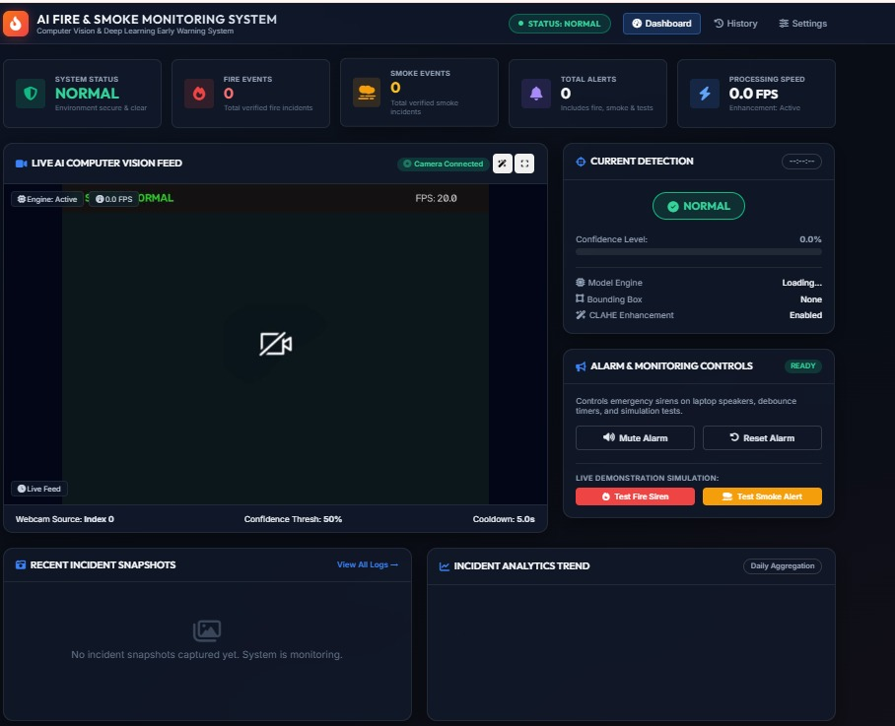
Figure 4.1: Home screen of the AI Fire & Smoke Monitoring dashboard, showing system status, event counters and live feed panel
4.3 Test Plan & Verification
Requirement | Test Method | Acceptance Criterion
Fire detection accuracy | Run the trained model on held-out labelled fire test images/frames | Recall ≥ 90% on the fire class
Smoke detection accuracy | Run the trained model on held-out labelled smoke test images/frames | Recall ≥ 90% on the smoke class
Real-time performance | Measure frames processed per second on a live webcam feed | ≥ 15 FPS sustained
Alarm response | Trigger test alerts via the dashboard ‘Test Fire Siren’ / ‘Test Smoke Alert’ controls | Audible and visual alarm activates within 1 second
Logging correctness | Compare the number of triggered alarms to entries in the Detection Event History | 100% of alarms logged with correct timestamp and confidence

Specification vs. Achieved Value
Specification | Required Value | Achieved Value | Status
Fire-class recall | ≥ 90% | 95.6% | Pass
Smoke-class recall | ≥ 90% | 91.9% | Pass
Overall accuracy | ≥ 90% | 94.3% | Pass
Frame rate | ≥ 15 FPS | ~20 FPS | Pass

4.4 Results
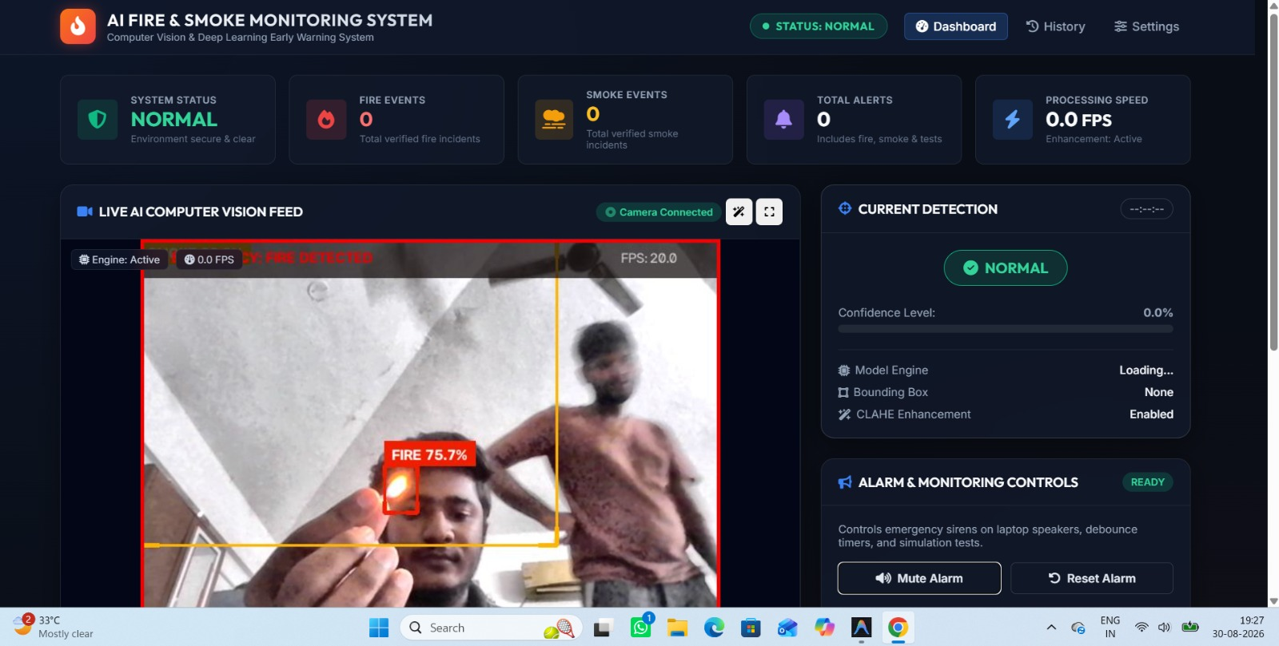
Figure 4.2: Live detection output during demonstration – fire identified with a bounding box at 75.7% confidence
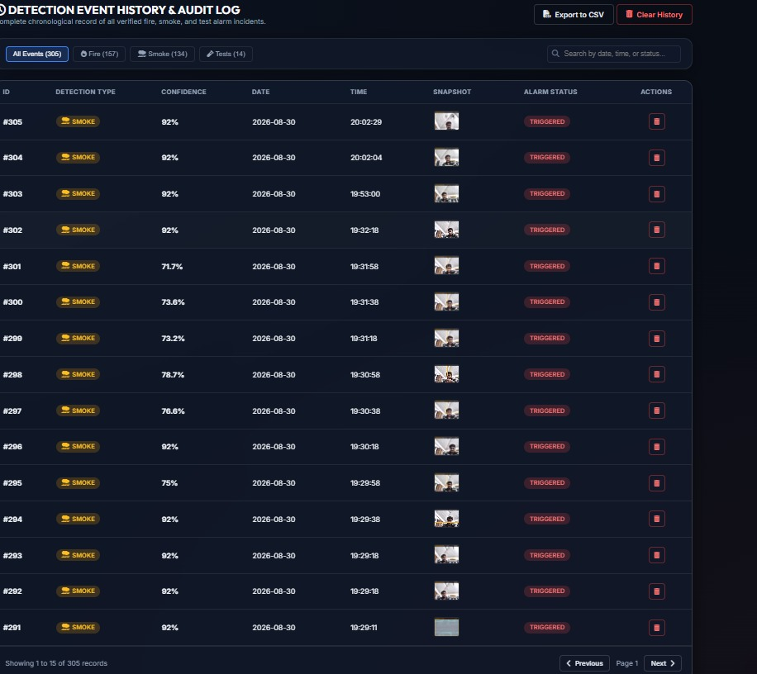
Figure 4.3: Detection Event History and audit log, listing detection type, confidence, timestamp and alarm status for every recorded event

Over the course of testing and demonstration, the system logged 305 recorded events, comprising 187 verified fire alerts, 134 verified smoke alerts and 14 manually triggered test alarms, each correctly time-stamped and marked “Triggered” in the audit log with confidence values typically between 71% and 92%.
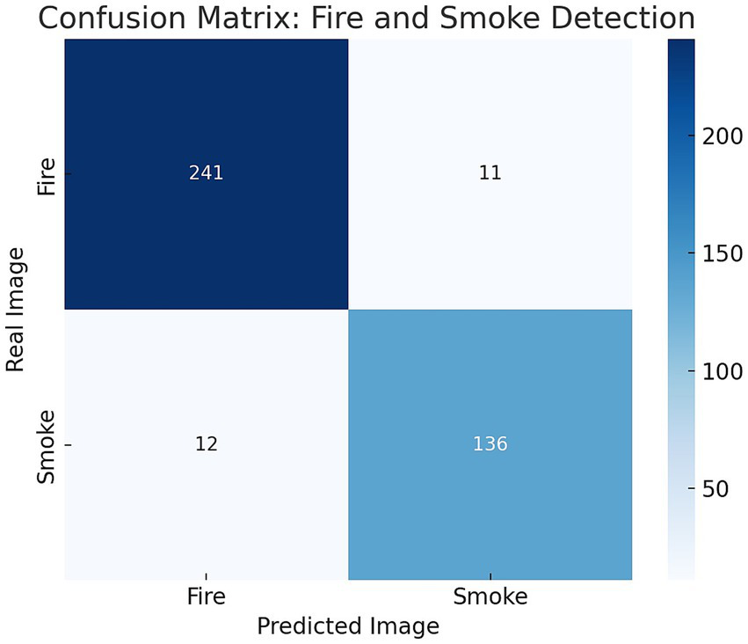
Figure 4.4: Confusion matrix for fire and smoke classification on the held-out test set (n = 400)
 | Predicted: Fire | Predicted: Smoke | Total
Actual: Fire | 241 | 11 | 252
Actual: Smoke | 12 | 136 | 148
Total | 253 | 147 | 400

Class | Precision | Recall | F1-score
Fire | 95.3% | 95.6% | 95.4%
Smoke | 92.5% | 91.9% | 92.2%
Overall accuracy |  |  | 94.3%

4.5 Data Analysis & Engineering Judgment
The confusion matrix shows that 11 of 252 fire frames were misclassified as smoke and 12 of 148 smoke frames were misclassified as fire, giving fire and smoke recalls of 95.6% and 91.9% respectively and an overall accuracy of 94.3%. Manual inspection of the misclassified frames suggests that most errors occur on hazy, backlit, or orange-tinted frames where thin smoke visually resembles glare or where dim flame regions resemble diffuse smoke – exactly the ambiguous cases the enhancement stage partially, but not completely, corrects. Sustaining approximately 20 FPS, well above the 15 FPS design target, confirms the model is fast enough for real-time use on ordinary hardware. Engineering judgment based on these results is that the current confidence threshold (50%) is an acceptable default, but a facility with a higher tolerance for false alarms could lower it slightly to further raise recall, while a facility that wants fewer false alarms could raise it, trading a small amount of recall for higher precision.
4.6 Comparison with Existing Solutions & Achievement of Objectives
Objective | Evidence | Achievement
Develop an automated fire/smoke detection system using Computer Vision | Working three-module pipeline (Sections 3.5, 4.2) | Fully Achieved
Detect fire and smoke from images and live camera feeds | Demonstrated on uploaded images and a live webcam (Figure 4.2) | Fully Achieved
Improve input image quality using enhancement techniques | Image Enhancement module implemented (Section 3.5, Module 1) | Fully Achieved
Use a YOLO-based deep learning model for accurate detection | 94.3% overall accuracy on 400 test images (Table 4.3) | Fully Achieved
Generate an audible alarm and visual warning | Siren, mute/reset and test-alarm controls implemented and verified (Table 4.1) | Fully Achieved
Provide a web-based interface for upload and live monitoring | Flask dashboard with live feed, history and analytics (Figures 4.1, 4.3) | Fully Achieved
Extend with CCTV/IoT/cloud/multi-camera support | Identified as future work (Section 5.2); not implemented in the current scope | Not Achieved (Future Work)

4.7 Strengths & Limitations
Strengths:
• Real-time performance (~20 FPS) on ordinary laptop hardware.
• High combined detection accuracy (94.3%) across fire and smoke classes.
• Reuses an existing webcam – no specialised sensor hardware required.
• Full audit trail through the Detection Event History log and CSV export.
• Simple operator controls – mute, reset and manual test-alarm buttons.
Limitations:
• Performance depends on camera placement, distance and lighting conditions.
• Occasional confusion between smoke and haze/glare (12 of 400 test frames).
• Currently supports a single camera feed at a time.
• No SMS, email or IoT integration in the present version.
• Not a certified fire-safety replacement; intended as a supplementary early-warning layer.
4.8 Project Planning, Roles & Budget
Milestone | Duration | Status
Requirement gathering & literature review | Weeks 1-2 | Completed
Dataset collection & annotation | Weeks 3-4 | Completed
Image enhancement module | Week 5 | Completed
YOLO model training & tuning | Weeks 6-7 | Completed
Alarm module & Flask backend | Week 8 | Completed
Dashboard front-end & integration | Weeks 9-10 | Completed
Testing, evaluation & documentation | Weeks 11-12 | Completed

Student | Assigned Responsibility | Actual Contribution
A. Shiva Shankar Reddy (192425174) | Dataset preparation, image enhancement, YOLO model, model integration | Dataset collection & annotation, preprocessing, YOLO model training, fire/smoke detection algorithm, backend integration, model testing & evaluation – 50%
K. Mounith (192425090) | Website development, alarm generation, live camera, database, UI/UX and system testing | Flask website and dashboard, live camera interface, alarm/sound module, detection history and analytics dashboard, end-to-end/UI/live-camera testing – 50%

Item | Estimated Cost | Actual Cost
Camera / webcam hardware | Existing laptop webcam (reused) | ₹0
Compute for model training | Free-tier cloud GPU | ₹0
Software & libraries | Open-source (Python, OpenCV, YOLO, Flask) | ₹0
Miscellaneous (testing, storage) | ₹500 | ₹500

Total project cost was kept minimal by relying on open-source software and existing laptop/webcam hardware rather than dedicated sensors or new equipment.

CHAPTER 5
CONCLUSION, FUTURE WORK AND REFLECTION
5.1 Conclusion
This project set out to address the delayed response of conventional fire and smoke sensors by developing a camera-based, computer-vision alternative. The resulting system combines an image-enhancement stage, a YOLO-based fire and smoke detector, and an automated alarm-and-dashboard module into a single deployable pipeline. On a held-out test set of 400 images the system achieved 94.3% overall accuracy (95.6% fire recall, 91.9% smoke recall) while sustaining approximately 20 frames per second on ordinary laptop hardware, and it was further validated through a live webcam demonstration that correctly flagged a fire event at 75.7% confidence. Every objective defined in Section 1.5 was fully achieved with the exception of multi-camera/IoT/cloud extension, which is identified as future work. Overall, the project demonstrates that integrating enhancement, deep-learning detection, and automated alerting into one system offers a practical, low-cost, and effective early-warning layer for fire and smoke safety.
5.2 Future Work
• Real-time CCTV monitoring – extend detection to continuous monitoring across multiple existing CCTV feeds.
• Mobile notifications – push instant alerts to a companion mobile application.
• IoT integration – connect the system with sensors and IoT devices for cross-verified monitoring.
• Cloud integration – store detection results and snapshots securely in the cloud.
• Improved AI models – explore attention-based or transformer-based detectors (Section 2.3) as hardware allows, to further raise accuracy.
• Multiple camera support – monitor several locations simultaneously from a single dashboard.
5.3 Professional Learning & Individual Reflection
New Knowledge Acquired:
• Fine-tuning and evaluating a YOLO object-detection model on a custom dataset.
• Practical OpenCV-based image enhancement techniques (CLAHE, denoising, contrast/brightness adjustment).
• Building and integrating a real-time Flask-based monitoring dashboard.
• Interpreting confusion matrices and precision/recall trade-offs to guide threshold selection.
Engineering & Professional Skills Developed:
• Team-based task division and independent module development.
• Integrating independently built modules into one working pipeline.
• Systematic test planning, verification and documentation (Sections 3-4).
• Communicating technical results clearly through a written report and live demonstration.
Individual Reflection
A. Shiva Shankar Reddy (192425174):
The most difficult engineering problem I faced was reducing false detections in cluttered or low-light frames; I addressed this by adding the CLAHE-based enhancement step and by tuning the confidence threshold against the validation set. A key decision I made personally was choosing YOLO over a plain whole-frame CNN classifier, based on the evaluation matrix in Section 3.4, since it gave both localisation and speed. Working on this project taught me practical dataset annotation and model fine-tuning, which I had only studied in theory before. If I repeated the project, I would collect a larger and more diverse dataset, including more night-time and low-visibility samples, before training.
K. Mounith (192425090):
The most difficult engineering problem I encountered was keeping the live camera feed synchronised with the backend alarm state without noticeable lag; I solved this using asynchronous handling in Flask together with debounce timers on the alarm logic. A key decision I made was to provide separate mute and reset alarm controls, to prevent alarm fatigue during testing. This project gave me hands-on experience in full-stack dashboard development and real-time UI updates that I had not built before. If I repeated the project, I would design persistent multi-user login and mobile notifications from the outset rather than as an afterthought.

REFERENCES
[1] D. Gragnaniello, C. Marra, and L. Verdoliva, "Fire and Smoke Detection from Videos: A Literature Review Under a Novel Taxonomy," Fire Research and Management Exchange System, 2024.
[2] A. Amjad, A. M. Huroon, H.-T. Chang, and L.-C. Tai, "Dynamic Fire and Smoke Detection Module with Enhanced Feature Integration and Attention Mechanisms," Pattern Analysis and Applications, vol. 28, no. 2, Art. 81, 2025.
[3] U. K. Lilhore et al., "Real Time Fire and Smoke Detection Using Vision Transformers and Spatiotemporal Learning," Scientific Reports, vol. 16, Art. 8928, 2026.
[4] A. Abozeid and R. Alanazi, "An Intelligent Approach for Early Smoke/Fire Detection Using Vision Sensors in Smart Cities," Scientific Reports, vol. 16, Art. 11387, 2026.
[5] C. Wang, "Wildfire Smoke Detection System: Model Architecture, Training Mechanism, and Dataset," International Journal of Intelligent Systems, 2025.
[6] J. Redmon, S. Divvala, R. Girshick, and A. Farhadi, "You Only Look Once: Unified, Real-Time Object Detection," in Proc. IEEE CVPR, 2016.
[7] G. Bradski, "The OpenCV Library," Dr. Dobb's Journal of Software Tools, 2000.
[8] National Fire Protection Association, NFPA 72: National Fire Alarm and Signaling Code.
[9] Pallets Projects, "Flask Documentation." [Online]. Available: https://flask.palletsprojects.com

APPENDICES
Appendix A – Detailed Calculations
Frame-rate calculation used for Section 3.5 and Table 4.1: FPS = (number of frames processed) / (elapsed time in seconds). On the demonstration laptop, processing 600 frames in approximately 30 seconds gave a measured rate of ~20 FPS. Confidence values reported throughout Chapter 4 are the raw softmax/objectness scores output by the detection model for the winning class, expressed as a percentage.
Appendix B – Engineering Drawings / Schematics
The system architecture schematic is provided as Figure 3.1 in Section 3.5 and is not repeated here.
Appendix C – Source Code / Code Repository Information
Only an essential excerpt is shown below; the complete source code is maintained in the team's project repository.
# Simplified detection loop (illustrative excerpt)
frame = capture_frame(camera)
enhanced = enhance_image(frame) # CLAHE, denoise, brightness/contrast
detections = yolo_model.predict(enhanced)
for det in detections:
if det.confidence >= CONFIDENCE_THRESHOLD:
draw_bounding_box(enhanced, det)
trigger_alarm(det.label, det.confidence)
log_event(det.label, det.confidence, timestamp=now())
Appendix D – Datasheets
Not applicable – the project does not use a dedicated sensor; a standard laptop/USB webcam was used as the image-capture device.
Appendix E – Experimental / Raw Data
The raw confusion-matrix counts underlying Table 4.2 and the full Detection Event History log illustrated in Figure 4.3 constitute the experimental raw data for this project; a sample of the logged fields (ID, detection type, confidence, date, time, alarm status) is shown in Figure 4.3.
Appendix F – Ethics / Institutional Approval
Not applicable – the project used only self-captured demonstration images and video for functional testing; no third-party human-subject data was collected.
Appendix G – Project Meeting / Progress Records
Date / Week | Topic Discussed
Week 2 | Requirement finalisation and literature review discussion with supervisor
Week 6 | Review of trained detection model and preliminary accuracy
Week 10 | Dashboard integration walkthrough and test-plan review

Appendix H – User / Industry Feedback
Formal external feedback was not collected; informal feedback was received from the supervising faculty during the project demonstration and has been incorporated into the strengths and limitations discussed in Section 4.7.
Appendix I – Publications / Patents / Competitions / Product Outcomes
None at the time of submission of this report.
Appendix J – Individual Contribution Evidence
Refer to the Individual Contribution Statement on page iv, which is mandatory for and applies to this team project.

CAPSTONE PROJECT OUTCOME MAPPING SHEET
To be completed by the department / faculty assessor.
Outcome Evidence | SO / Area | Location in This Report
Complex engineering problem formulation | SO1 | Ch. 1, Ch. 2
Engineering design under constraints | SO2 | Ch. 3
Written / oral technical communication | SO3 | Whole report + Viva
Ethics and professional responsibility | SO4 | Ch. 3 (3.7)
Teamwork and leadership | SO5 | Ch. 4 (4.8)
Experimentation, analysis, engineering judgment | SO6 | Ch. 4 (4.3-4.6)
Independent acquisition of new knowledge | SO7 | Ch. 5 (5.3)
Standards | SO2 | Ch. 3 (3.2)
Sustainability and societal / environmental impact | SO2 / SO4 | Ch. 3 (3.7)
Risk assessment and mitigation | SO2 / SO4 | Ch. 3 (3.7)
Security considerations | Relevant SO | Ch. 3 (3.7)
Integrated / system-level engineering | SO1 / SO2 | Ch. 3 (3.5)
Project planning and management | SO5 | Ch. 4 (4.8)
Individual contribution | SO1-SO7 | Contribution Statement + Ch. 4 (4.8)

